**Project: MSS60**

**Module: EVTMoment Realization**

**Authorization**

**Author (ZS-M-57) Date**

**Approved (ZS-M-57) Date**

**Approved (EA-E-2) Date**

**Changes:**

|  |  |  |
| --- | --- | --- |
| **Version** | **Date** | **Comment** |
| r310 | 31.08.2004 | First version |
| r320 | 27.10.2004 | Add Minihub |
| r320 | 06.11.2004 | Conversion of air mass to [mg/l*ASP] |
| r320 | 06.11.2004 | Pre-position angle refers to ES |
| r330 | 04.12.2004 | Minihub changed from 4V to 3V |
| r370 | 27.03.2005 | Brake operation 4takt added |
| r390 | 25.04.2005 | ti_ende and it control edges expanded at the start of K->KF  Changed the calculation of the density correction in the start |

**Table**

Amendments 2

1 Functional description 4

1.1 Function diagram (overview) 4

1.2 Functional diagram basic control edges 5

1.3 Description 6

1.4 Do not apply Bit 7

1.5 Cylinder-individual control edge correction 8

1.6 Inlet-Closing Corrections 9

1.6.1 Density correction has been replaced by DKR! 9

1.6.2 ZW efficiency correction (not yet implemented!) 9

1.7 Outlet-Opens Delay 9

1.8 Minihub 10

1.9 Air mass adaptation (not yet implemented!) 10

1.10 Conversion of ml_soll_korr_eff to injection time 11

1.11 Conversion of ml_soll_korr_eff into air mass flow 11

1.12 Conversion of air mass flow into relative filling 11

1.13 Function diagram air mass adaptation 13

2 Data of moment realization 14

# Description

## Function diagram (overview)

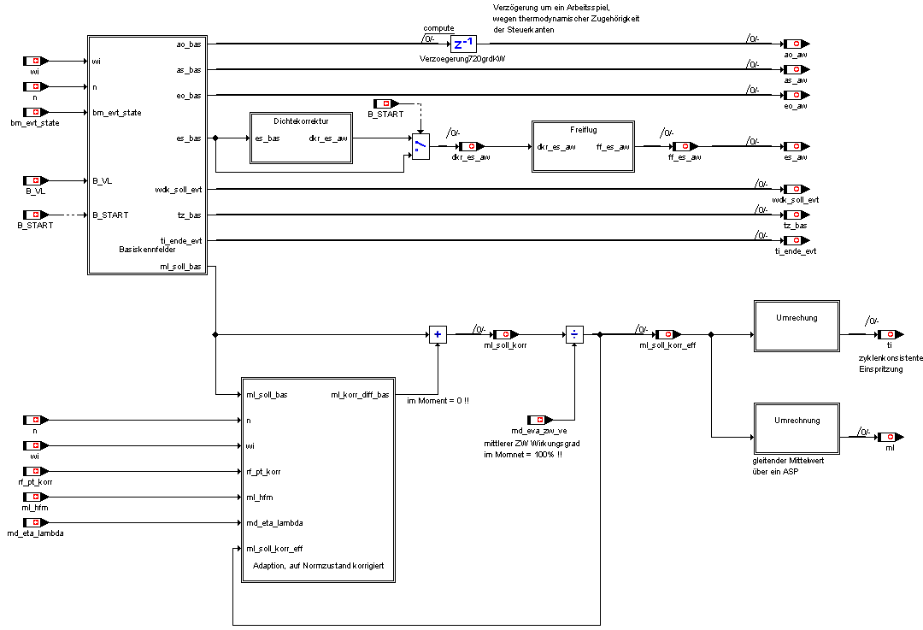

## Functional diagram basic control edges

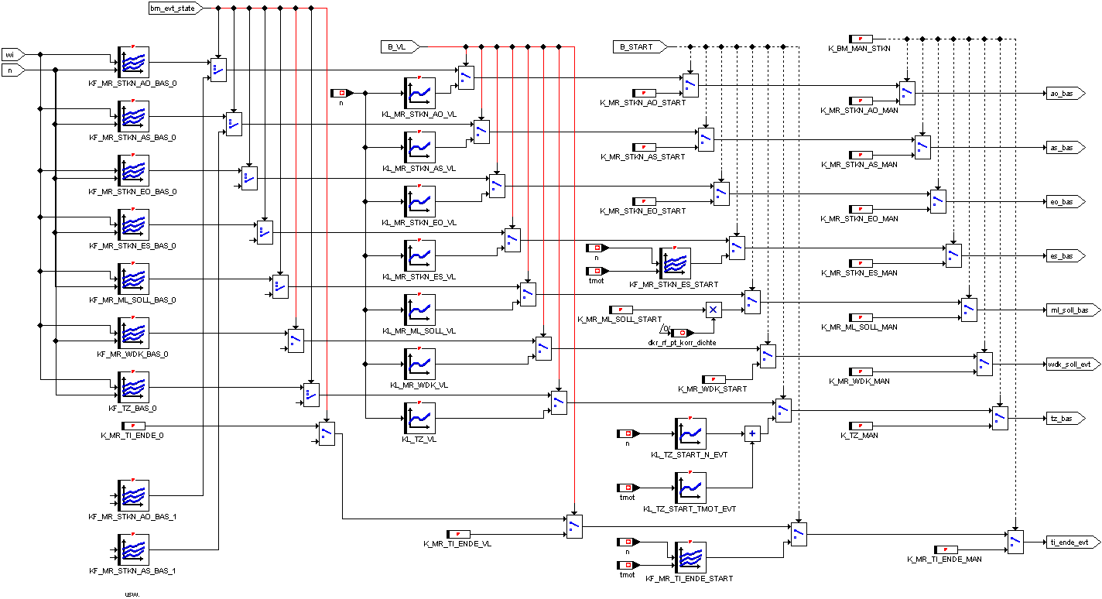

## Description

According to the applicable operating mode **bm_evt_state** (see operating mode manager), the moment realization selects the basic characteristic fields of this operating mode:

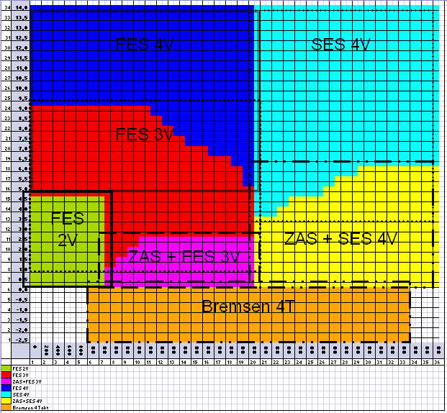

For vollast (B_VL =**1**), a baseline set isselected. Aseparate record is selected for the start (**B_START = 1**). In addition, a manually regenerated set of control parameters can be selected via the parameter **B_MAN_STKN.**

The basic control parameter set consists of:

* **eo_bas** (inlet-opens-control edge in °KW according to ZündOT)
* **as_bas** (exhaust-close-control edge in °KW according to ZündOT))
* **es_bas** (inlet-closing-control edge in °KW according to ZündOT)
* **ao_bas** (outlet-opens-control edge in °KW according to ZündOT)
* **wdk_soll_evt** (basic throttle position in %)
* **tz_bas** (base ignition angle in °KW before ZündOT))
* **ti_ende_evt** (injecting in °KW before inlet Closes)
* **ml_soll_bas** (base air mass in mg/l*ASP)

The DISA is held in the power position in all modes except full load. At the full load, a speed query NMIN_DISA < n < NMAX_DISA whether to switch in moments position (see Disa.doc).

The control parameters (basic parameters + corrections) are cycle-consistentexcept for the DISA position and the throttleposition, i.e. related to a working play of a cylinder (see operating mode manager).

DISA and throttle valve are synchronized as well as possible with the other cycle-synchronous control parameters by speed-dependent drive time offsets.

The basic parameters are stationary at 960mbar and 20°C.

The characteristic fields are applied via **wi** and **n.**

## Do not apply Bit

In order for the valve control to correctly apply the control edges in each operating mode, a so-called "do not apply bit" (**bm_msk_stkn**) is set by theMSS60 and transmitted via CAN. In this bit, it is encoded which control edges are used and which are not applied.

The bit is encoded as follows:

|  |  |  |  |  |  |  |  |
| --- | --- | --- | --- | --- | --- | --- | --- |
| as2 | ao2 | as1 | ao1 | es2 | eo2 | es1 | eo1 |

In the case of cylinder shutdown, for example, the calculated control edges for cylinders 2 and 3 may not be executed; in this bit is then the value 00000000 (00h) for these cylinders.

|  |  |  |  |  |
| --- | --- | --- | --- | --- |
| State | Cylinder 1 | Cylinder 2 | Cylinder 3 | Cylinder 4 |
| 0 | Ffh | 00h | 00h | Ffh |
| 1 | 3Fh / CFh (180°) | 00h | 00h | 3Fh / CFh (180°) |
| 2 | 3Ch / C3h (720°) | 3Ch / C3h (720°) | 3Ch / C3h (720°) | 3Ch / C3h (720°) |
| 3 | 3Fh / CFh (720°) | 3Fh / CFh (720°) | 3Fh / CFh (720°) | 3Fh / CFh (720°) |
| 4, 5, 13 | Ffh | Ffh | Ffh | Ffh |
| 6 | F0h | F0h | F0h | F0h |

In **addition,** the valves can be completely closed via the parameter K_MR_VENTZU_EIN in brake mode 4V (**bm_msk_stkn=0)**.

## Cylinder-individual control edge correction

In order to be able to equate the cylinder filling and the residual gas content of the cylinders, cylinder-individual control edge corrections are required.

Therefore, the 4 control edges (ao_bas, as_bas, eo_bas, es_bas) canbe changed with an offset. These offsets, each an array for ao/eo/es can be set as a manual correction via the application system.

The name of the arrays is:

K_MR_AO_KORR[1..8]

K_MR_AS_KORR[1..8]

K_MR_EO_KORR[1..8]

K_MR_ES_KORR[1..8]

The index of arrays refers to the physical cylinder. So: Index=1 is for cylinder 1 index 8 for cylinder 8 etc.

(last4.gif)

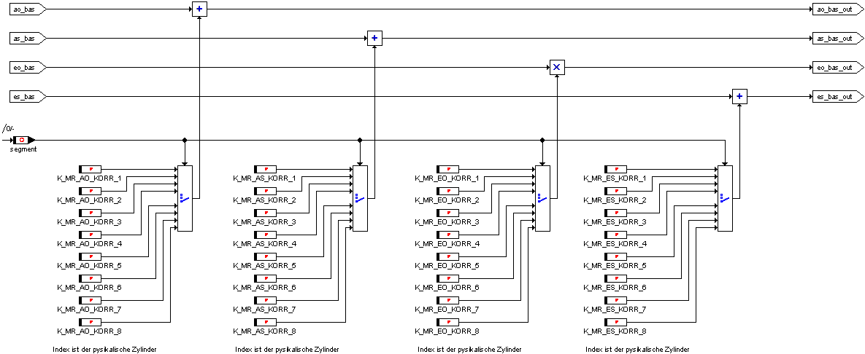

## Inlet-closing corrections

### Density correction has been replaced by DKR!

The ambient pressure and ambient temperature, which deviate from the standard state, are combined in the factor **rf_pt_korr** and compensated in an inlet-closing correction.

If **the Wi** and the same AÖ, AS and EÖ control edges remain the same, the inlet close is **KL_ES_VOLUM** converted KL_ES_VOLUM into an actual volume via a volume characteristic curve. Subsequently, the density ratio actual/set density leads to a new desired air volume. This is converted back into an inlet-closing control edge via the inverse characteristic **KL_ES_VOLUM_inv.**

This procedure keeps the load point constant under different environmental conditions and in particular does not change the thermodynamically relevant influencing variables(residual gas, etc).).

The inlet-closing correction is limited at the full load and in the top partial load.

### ZW efficiency correction (not yet implemented!)

Similarly, in THE case of ZW late positions, which are caused by knock control and other functions, the air mass is increased via the inlet-closing edge to compensate for the moment drop.

This correction is only applied for ZW-late position, which undesirably reduce the motor torque.

The correction is made using the same characteristic curves. The moment ratio actual-moment/max-moment, defined as ignition angle efficiency, is determined. The moment drop is compensated by an air mass increase (reverse value of the moment ratio actual-moment/max-moment).

The resulting control parameter sets keep the moment **wi** constant. The inlet-closing correction reduces the residual gas content at ignition angle late positions due to the constant remaining control edges (knocking inclination is reduced).

The inlet-closing correction due to late ignition angle leads to a higher air mass. This is opened in the air mass path over **md_eva_ve.**

## Exit-Opens Delay

The burnt fuel-air mixture, which is located in the cylinder, must also be pushed out with the AÖ control edge, which fits to the control edges with which the fresh air was sucked in. The control edge outlet Opens is therefore thermodynamically part of the previous working game.

However, since the calculation of the control edges is always carried out in the same segment, AÖ must be delayed by exactly one working play (720 grdKW) in order to be transferred to the valve control unit via CAN.

## Minihub

The Minihub operating state is used in the lower load range at low speeds and allows the engine to operate quietly.

The amplitude of the control valves is specified by the MSS60, transferred via CAN to the dSpace systems and regulated there. The ministroke is currently only intended for the inlet valves, the outlet valves are operated with full stroke in alternating mode (3V) (**mr_minilift_ex**  **= 0**).

With the help of the application constants **K_MR_MINILIFT_INT,** the amplitude can be set.

The **mr_minilift_int** variable displays the value of the set valve stroke height, which is passed to the CAN. Due to programmatic reasons of the dSpacesystems,  **mr_minilift_int** must be sent to the CAN delayed by one segment (180grdKW).

## Air mass adaptation (not yet implemented!)

The aim of the air mass adaptation is to compensate for air mass errors in the piloted air mass calculation. A comparison of the measured air mass **ml_ist_aw** to the piloted air mass **ml_soll_bas** is carried out. The difference is fed to an adaptation characteristic field via a PT1 filter.

Actual air mass determination is carried out via HFM (ml) and lambda probe adaptation (**f_ti_a*ml_soll_bas**). The actual air mass determination can be weighted between HFM and lambda probe adaptation over the characteristic KF_FAK_ML_HFM_LAM. **KF_FAK_ML_HFM_LAM**

Adaptation conditions:

* Lambda regulation is in progress
* wi below threshold
* B_TL
* Motor operating warm

**ml_korr_diff_bas** < Threshold; otherwise error detection

**ml_korr_diff_bas = 0 !!!**

The air mass adaptation is not yet implemented!!! Needs to be specified in more detail. A separate adaptation characteristic field would have to be stored for each mode of operation.

## Conversion of ml_soll_korr_eff to injection time

The load size **tl** and from this also the injection time **ti** is calculated in a cycle-consistent way from **ml_soll_korr_eff.**

The injection time **ti** will be calculated cycle-consistent for each cylinder and every working game.

## Conversion of ml_soll_korr_eff into the air mass flow

The target air mass flow is not required for the basic application. For exhaust gas temperature models or adaptation with the HFM, the target air mass flow can be calculated over the moving average via a working play (4 segments with 4 cylinders):



The air mass flow results from the moving average formation of all cylinders. For a switched-off **cylinder, the**value 0 is used for ml_soll_korr_eff**i** i. The air mass flow **ml** is output in [kg/h].

## Conversion of air mass flow into relative filling

For the conversion to rf is calculated according to the following formula:



The relative fill **rf** has the unit [%].

## Function diagram air mass adaptation

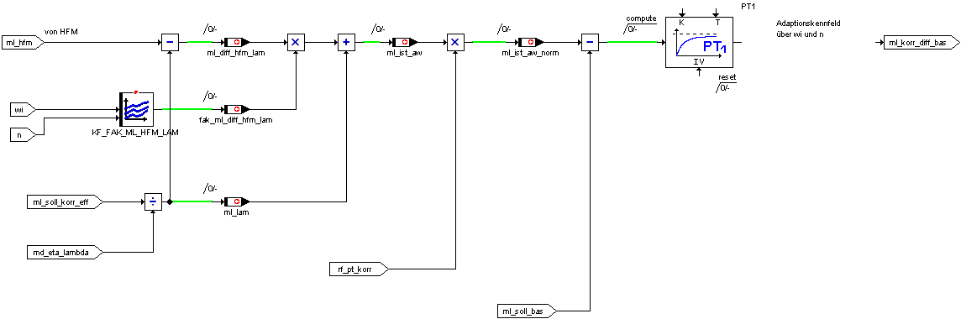

# Data dhe Moment realization

The function is calculated in the angle-synchronous task.

Description of the calculated variables:

|  |  |  |
| --- | --- | --- |
| ao_aw | Outlet Opens, current value, delayed by 720 grdKW | Uw |
| as_aw | Outlet Closes, current value | Uw |
| eo_aw | Inlet Opens, current value | Uw |
| es_bas | Inlet, Closes, base | Uw |
| es_aw | Inlet Closes, current value (density corrected) | Uw |
| ml_soll_bas | Should air mass, base [mg/l*ASP] | Uw |
| ml_soll_korr | Target air mass, corrected with adaptation | Uw |
| ml_soll_korr_eff | Target air mass, corrected with adaptation and ZW | Uw |
| ml_hfm | Air mass of HFM [kg/h] | Uw |
| Ml | Air mass [kg/h] calculated on basic air mass qualifiers | Uw |
| ml_korr_diff_bas | Adapted delta target air mass----------- = 0!!! | Uw |
| ml_diff_hfm_lam | ---------------------- |  |
| wdk_soll_evt | Target throttle angle in % | Uw |
| tz_bas | Base ignition angle | Sw |
| ti_ende_evt | Pre-position angle evt related to ZündOT | Uw |
| bm_msk_stkn | do not apply bit | Ub |
| mr_minilift_int | Amplitude Minihub Inlet | Ub |
| mr_minilift_ex | Amplitude Minihub Outlet = 0 | Ub |

Description of the application data:

|  |  |  |
| --- | --- | --- |
| K_TI_ENDE_x | Preposition angle at bm_evt_state=x | Uw |
| K_TI_ENDE_VL | Pre-position angle for bulk load operation | Uw |
| KF_TI_ENDE_START | Pre-storage angle for start | uw/uw/uw |
| K_TI_ENDE_MAN | Pre-storage angle for manual mode | Uw |
| B_MAN_STKN | Switching to manual mode | Ub |
| K_MR_VENTZU_EIN | manual holding of the valves only for brakes | Ub |
| K_STKN_AO_MAN | Exhaust Opens for manual mode | Uw |
| K_STKN_AS_MAN | Exhaust Closes for manual mode | Uw |
| K_STKN_EO_MAN | Inlet Opens for manual mode | Uw |
| K_STKN_ES_MAN | Inlet Closes for manual mode | Uw |
| K_ML_SOLL_MAN | Should air mass for manual mode | Uw |
| K_WDK_MAN | Throttle angle for manual mode | Uw |
| K_TZ_MAN | Ignition angle for manual mode | Sw |
| K_STKN_AO_START | Outlet Opens for Start | Uw |
| K_STKN_AS_START | Outlet Closes for Start | Uw |
| K_STKN_EO_START | Entrance Opens for Start | Uw |
| KF_STKN_ES_START | Entrance Closes for start | uw/uw/uw |
| K_MR_MINILIFT_INT | Amplitude Minihub for inlet | Ub |
| K_ML_SOLL_START | Should air mass for start-up | Uw |
| K_WDK_START | Throttle angle for start | Uw |
| KL_TZ_START_N_EVT | Ignition angle at start f(n) | uw/sw |
| KL_TZ_START_TMOT_EVT | Ignition angle at start f(tmot) | ub/sw |
| KL_STKN_AO_VL | Exhaust Opens for bulk load operation | uw/uw |
| KL_STKN_AS_VL | Exhaust Closes for bulk load operation | uw/uw |
| KL_STKN_EO_VL | Inlet Opens for bulk load operation | uw/uw |
| KL_STKN_ES_VL | Inlet Closes for bulk load operation | uw/uw |
| KL_ML_SOLL_VL | Should air mass for bulk load operation | uw/uw |
| KL_WDK_VL | Throttle angle for full load operation | uw/uw |
| KL_TZ_VL | Ignition angle for full-load operation | uw/sw |
| KL_ES_VOLUM | Conversion Inlet Closes -> Volume | uw/uw |
| KL_ES_VOLUM_inv | inverse characteristic of KL_ES_VOLUM not applable! | uw/uw |
| KF_STKN_AO_BAS_x | Outlet Opens at bm_evt_state=x | uw/uw/uw |
| KF_STKN_AS_BAS_x | Outlet Closes at bm_evt_state=x | uw/uw/uw |
| KF_STKN_EO_BAS_x | Inlet Opens at bm_evt_state=x | uw/uw/uw |
| KF_STKN_ES_BAS_x | Inlet Closes at bm_evt_state=x | uw/uw/uw |
| KF_ML_SOLL_BAS_x | Should air mass at bm_evt_state=x | uw/uw/uw |
| KF_WDK_BAS_x | Throttle angle at bm_evt_state=x | uw/uw/uw |
| KL_WDK_BAS_6 | Throttle angle at bm_evt_state=6 (brakes 4T) | uw/uw |
| KF_TZ_BAS_x | Base ignition angle at bm_evt_state=x | uw/uw/sw |